# SALES Pre-Computation

# Original Query

SELECT cate.category_id

,cust.customer_id

,sum(quantity)

,sum(price)

FROM (

SELECT category_id

,sum(price) AS dollar_value

FROM sales.category NATURAL

INNER JOIN sales.product NATURAL

INNER JOIN sales.sale

GROUP BY category_id

ORDER BY dollar_value DESC limit 10

) AS cate

,(

SELECT customer_id

,sum(price) AS dollar_value

FROM sales.sale

GROUP BY customer_id

ORDER BY dollar_value DESC limit 10

) AS cust

,sales.sale s

,sales.product p

WHERE p.category_id = cate.category_id

AND s.customer_id = cust.customer_id

AND s.product_id = p.product_id

GROUP BY cate.category_id

,cust.customer_id

ORDER BY cate.category_id

|  |  |  |
| --- | --- | --- |
| Query Cost | Execution Time | Table IO |
| 206047.84..206048.04 | 6148.910 ms | 45667 |

### Query Plan:

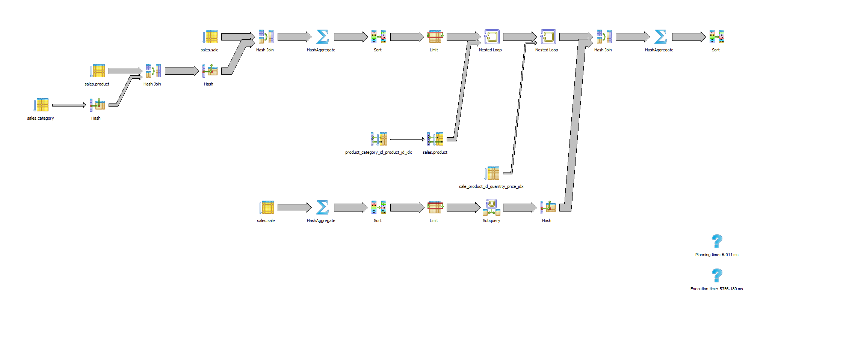

## New Query using Pre-Computed Table

WITH cate AS (

SELECT category_id

FROM sales.PRE_Category_Sale

ORDER BY dollar_value DESC limit 10

)

,cust as (

SELECT customer_id

FROM sales.PRE_Customer_Sale

ORDER BY dollar_value DESC limit 10

)

SELECT cate.category_id

,cust.customer_id

,sum(quantity)

,sum(price)

FROM cate

,cust

,sales.sale s

,sales.product p

WHERE p.category_id = cate.category_id

AND s.customer_id = cust.customer_id

AND s.product_id = p.product_id

GROUP BY cate.category_id

,cust.customer_id

ORDER BY cate.category_id

|  |  |  |
| --- | --- | --- |
| Query Cost | Execution Time | Table IO |
| 27749.81..27750.01 | 49.866 ms | 9288 |

### Query Plan:

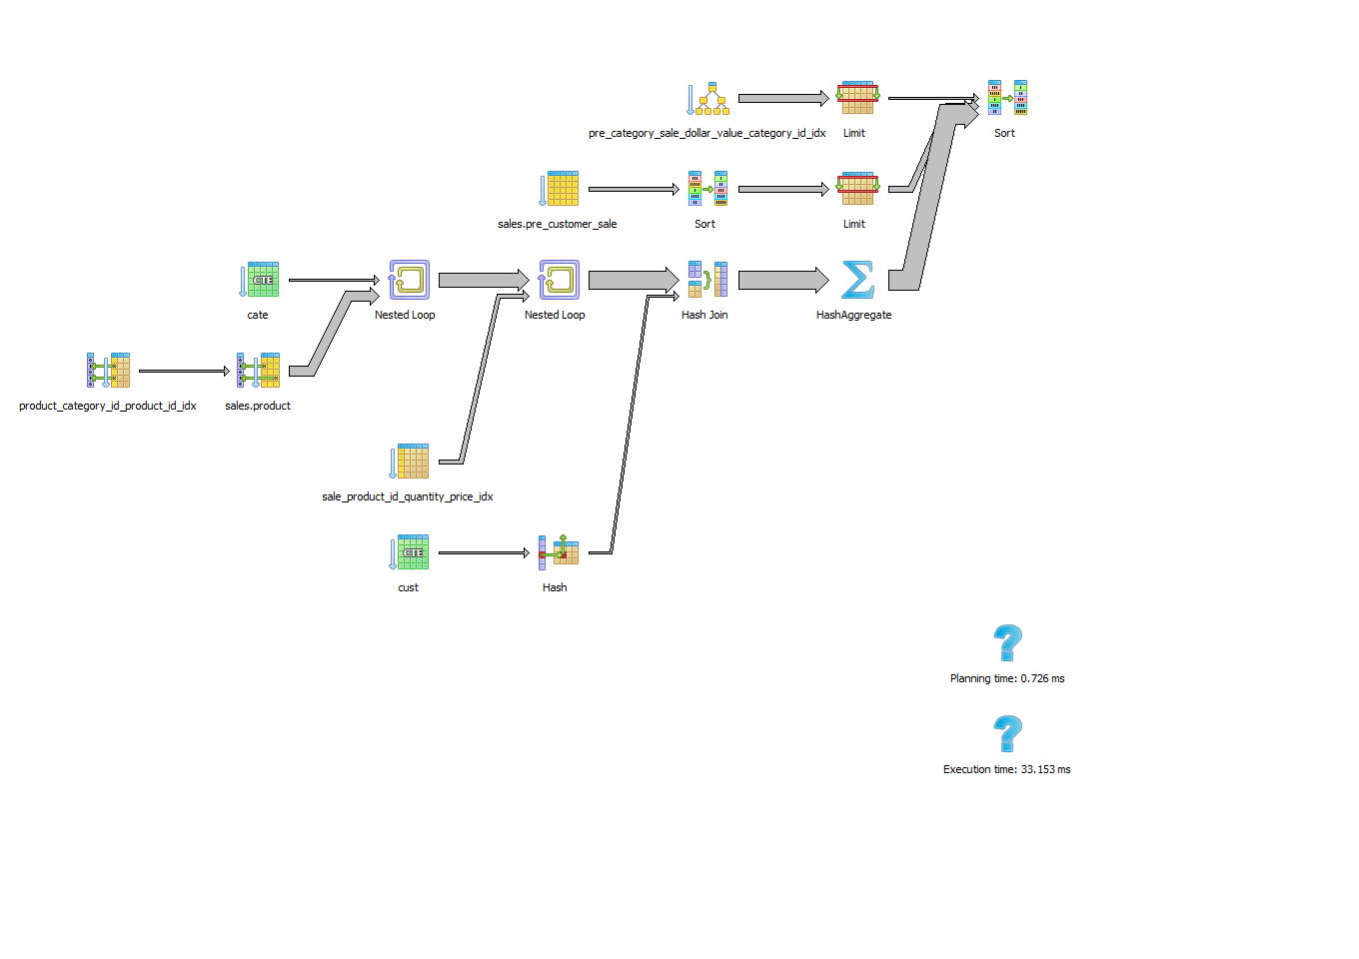

## Pre-Computation

Two pre-computed tables were created, one for each subquery: sales.PRE_Category_Sale, sales.PRE_Customer_Sale.

DROP TABLE IF EXISTS sales.PRE_Category_Sale ;

create table sales.PRE_Category_Sale as

SELECT category_id

,sum(price) AS dollar_value

FROM sales.category NATURAL

INNER JOIN sales.product NATURAL

INNER JOIN sales.sale

GROUP BY category_id;

DROP TABLE IF EXISTS sales.PRE_Customer_Sale;

create table sales.PRE_Customer_Sale as

SELECT customer_id

,sum(price) AS dollar_value

FROM sales.sale

GROUP BY customer_id;

CREATE or replace FUNCTION sales.FN_PRE_Category_Sale() RETURNS trigger AS $FN_PRE_Category_Sale$

BEGIN

UPDATE sales.PRE_Category_Sale as pre

SET dollar_value = pre.dollar_value + NEW.price

FROM sales.product as p

WHERE pre.category_id = p.category_Id

AND p.product_id = NEW.product_id;

IF NOT FOUND THEN

--no category_id updated

INSERT INTO sales.PRE_Category_Sale (category_id, dollar_value)

SELECT p.category_id, NEW.price

FROM sales.product p

WHERE p.product_id = NEW.product_id;

END IF;

RETURN NEW;

END;

$FN_PRE_Category_Sale$ LANGUAGE plpgsql;

DROP TRIGGER IF EXISTS trigger_Sale_Category ON sales.sale ;

CREATE TRIGGER trigger_Sale_Category

BEFORE INSERT ON sales.sale

FOR EACH ROW EXECUTE PROCEDURE sales.FN_PRE_Category_Sale();

CREATE or replace FUNCTION sales.FN_PRE_Customer_Sale() RETURNS trigger AS $FN_PRE_Customer_Sale$

BEGIN

UPDATE sales.PRE_Customer_Sale

SET dollar_value = dollar_value + NEW.price

WHERE customer_id = NEW.customer_id;

IF NOT FOUND THEN

--no category_id updated

INSERT INTO sales.PRE_Customer_Sale (customer_id, dollar_value)

SELECT NEW.customer_id, NEW.price;

END IF;

RETURN NEW;

END;

$FN_PRE_Customer_Sale$ LANGUAGE plpgsql;

DROP TRIGGER IF EXISTS trigger_Sale_Customer ON sales.sale ;

CREATE TRIGGER trigger_Sale_Customer

BEFORE INSERT ON sales.sale

FOR EACH ROW EXECUTE PROCEDURE sales.FN_PRE_Customer_Sale();

|  |  |
| --- | --- |
|  | Maintenance Cost |
| Update sales.Category_Sale | 0.70..157.24 |
| Update sales.Customer_Sale | 0.00..1.10 |
| Total Cost | 0.70..158.34 |

## Indexes

The following indexes were used by the trigger to improve maintenance cost or to improve the cost of the final query.

### pre_category_sale_dollar_value_category_id_idx

CREATE INDEX pre_category_sale_dollar_value_category_id_idx

ON sales.pre_category_sale

USING btree

(dollar_value DESC, category_id);

### product_category_id_product_id_idx

CREATE INDEX product_category_id_product_id_idx

ON sales.product

USING btree

(category_id, product_id);

### product_product_id_category_id_idx

CREATE INDEX product_product_id_category_id_idx

ON sales.product

USING btree

(product_id, category_id);

### sale_product_id_quantity_price_idx

CREATE INDEX sale_product_id_quantity_price_idx

ON sales.sale

USING btree

(product_id, quantity, price);

# Conclusion

|  |  |  |  |
| --- | --- | --- | --- |
|  | Query Cost | Execution Time | Table IO |
| Original Query | 206047.84..206048.04 | 6148.910 ms | 45667 |
| Using Pre-compute | 27749.81..27750.01 | 49.866 ms | 9288 |
| Difference | (178298.03..178298.03) | (6099.044) ms | (36379) |

Maintenance Cost for n=1 (1 new sale): 0.70..158.34

Given the maintenance execution cost of 158.34, using the pre-computation described would be optimal for values of n between 1 and 1,301.